To load multiple files from blob to gen2/Add new column/merge files
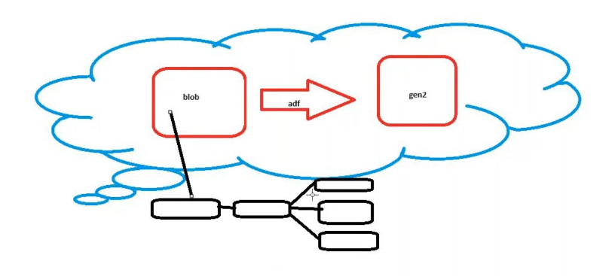
In blob create container upload the files(number should be sequence)s
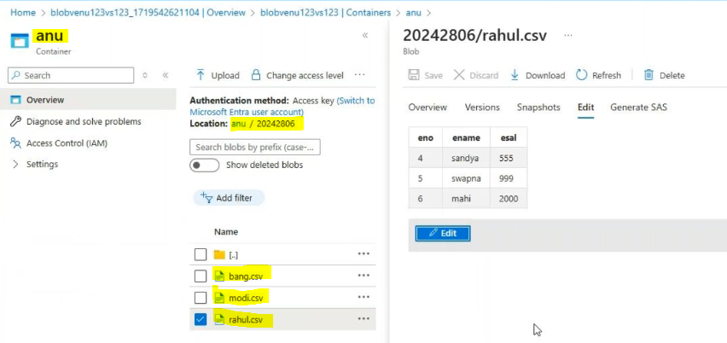
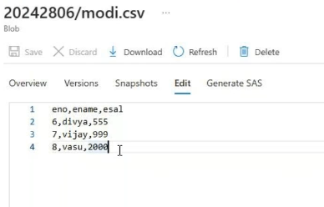
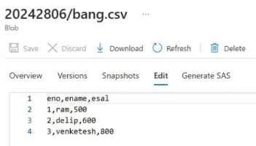
Create inked services for both sides
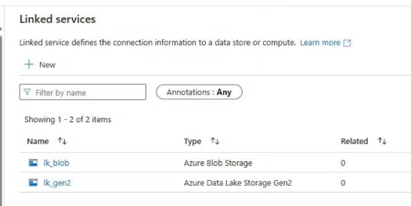
Create source_datasettake blobselect csv file
Here we take up to folder only
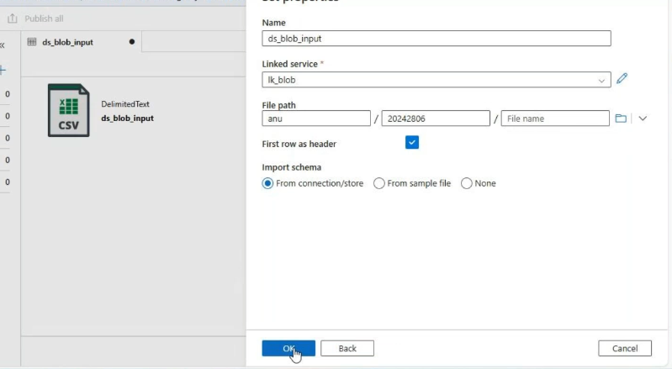
Create sink_datasettake gen2 select csv file
Here we need to write folder name

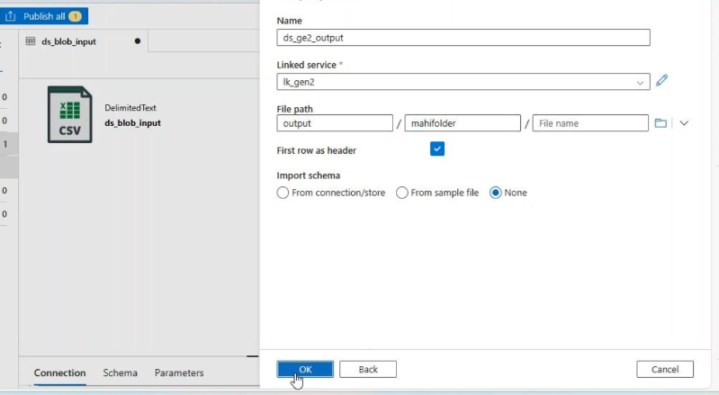

Create a pipeline copydata activity
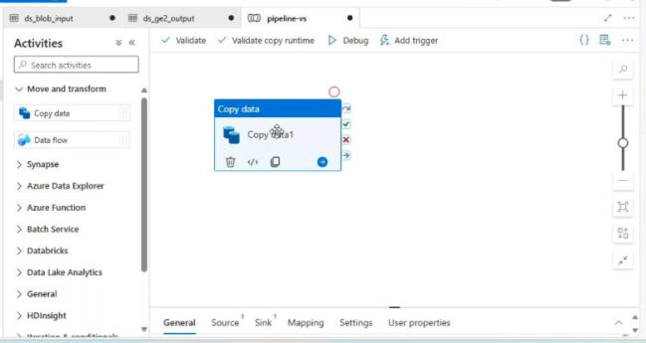
In copy data activity source side: add new column called todaydateandtime
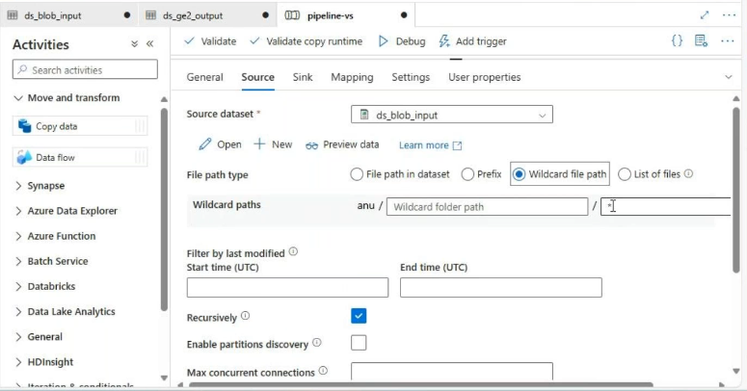

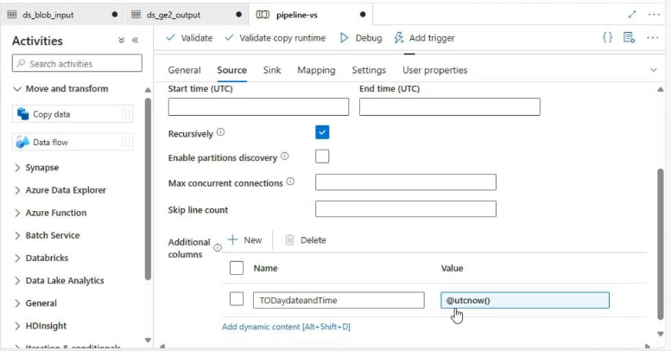

Copy data activity Sink_side:
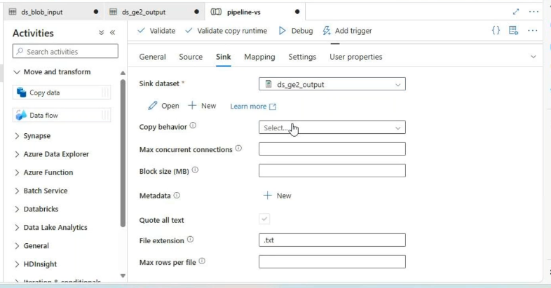
Validate and debug

Output:
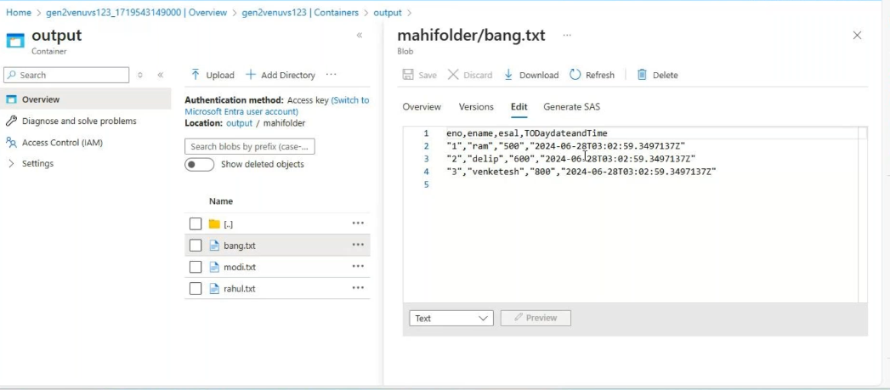

All files are in txt format but I want it in csv format
Then delete the mahifolder in sink side
In copy data activity sink side change file extension txt to csv
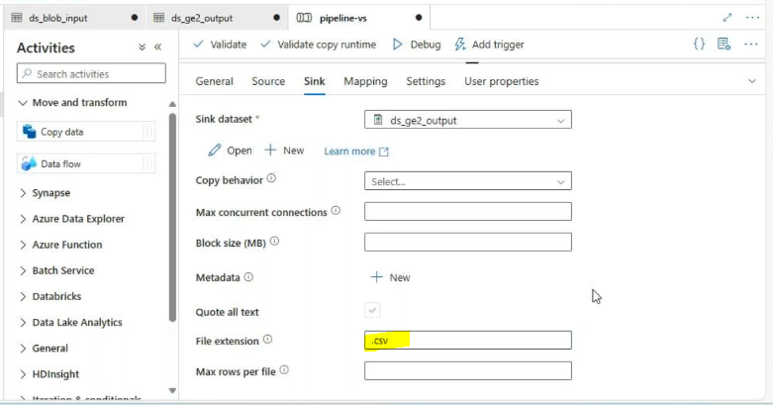
Validate the pipe line debug it
Result:
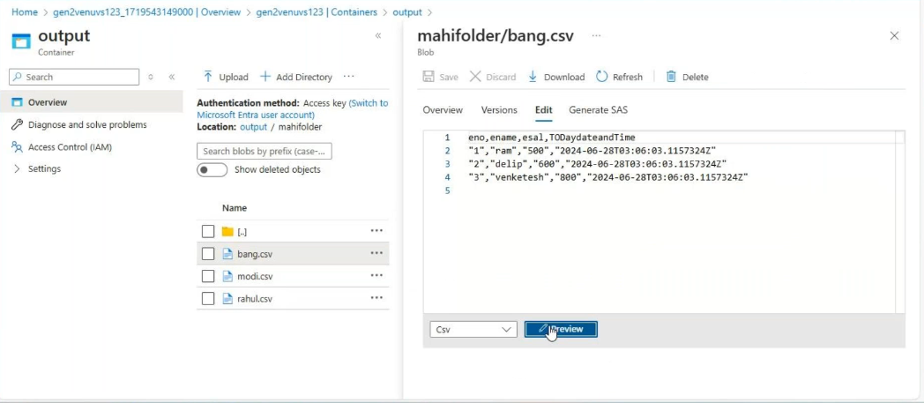

I want merge this all files into single file but schema should be same

Go to copy dataactivity sink_side change the copy behaviormergefiles

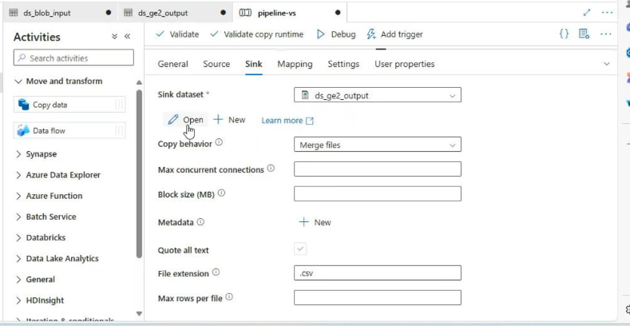

Go to sink_dataset in (copy data activity)change the folder name and file name
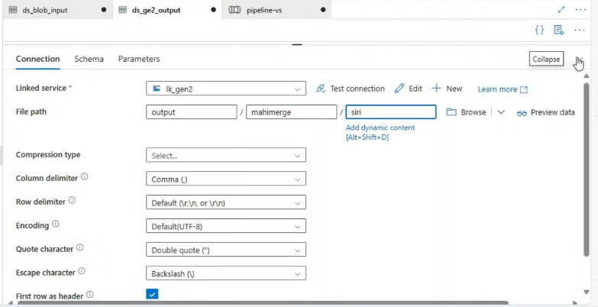

Validate and Debug
Result:
